PRN: 2020BTEIT00041   
DSA LAB ASSIGNMENT 1  
  
Q.1 Write a recursive program to generate factorial of number

ALGORITHM:

Algorithm fact(n)

Pre n is number being raised factorially

Post n! is returned

1.if (n equals 0)

1.return 1

2.else

1.(n\*fact(n-1))

3.end if

End fact

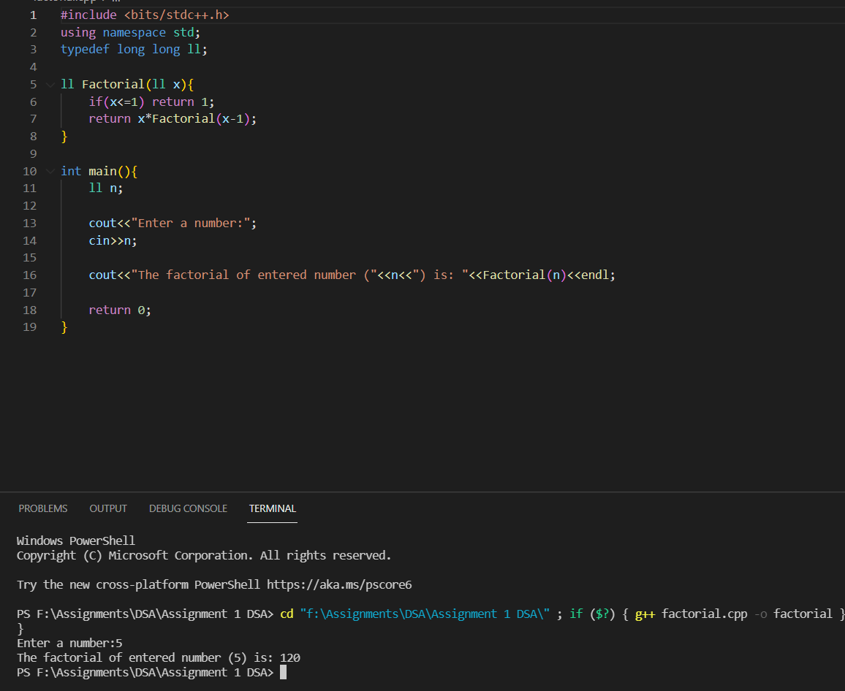

Q.2 Write a recursive program to display Fibonacci series

ALGORITHM:

Algorithm Fibonacci(i)

Pre i identifies Fibonacci number

Post return n Fibonacci numbers

1.if( i is 0)

1.return 0

2.else if (i is 1)

1.return 1

3.else

1. return (Fibonacci(i-1)+Fibonacci(i-2))

4.end if

End Fibonacci

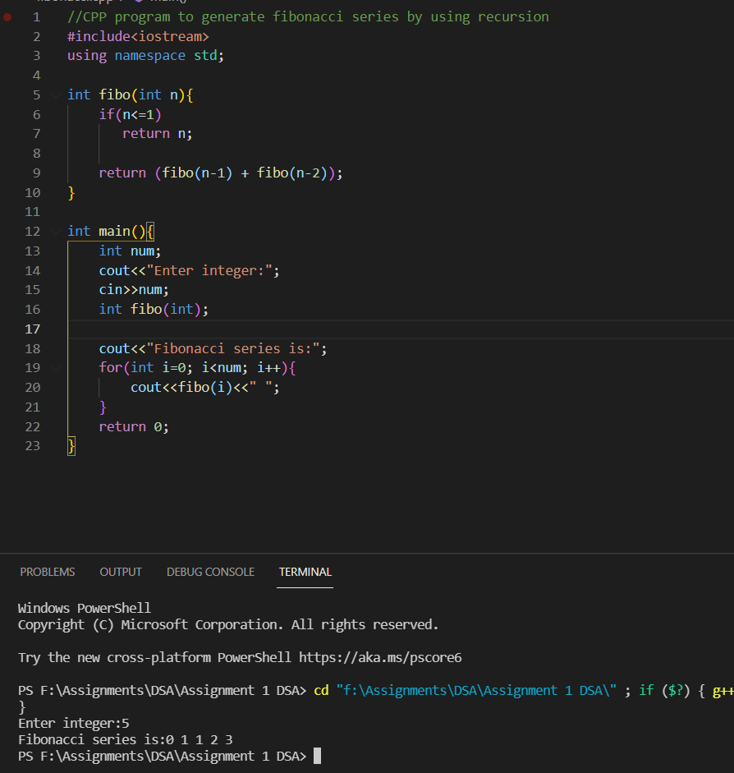

Q.3 Write a program to solve tower of Hanoi

ALGORITHM:

Algorithm towerofhanoi(n,sor,dest,person)

Pre The tower consists of n disks

Source,destination,auxillary

Post steps for moves forward

1.print(“Towers”,n,sor,dest,person)

2.if(n is 0)

1. return

3.towrofhanoi(n-1,sor,person,dest)

4.print(“move from”sor “to” dest)

5.towerofhanoi(n-1,person,dest,sor)

6.end if

End towerofhanoi

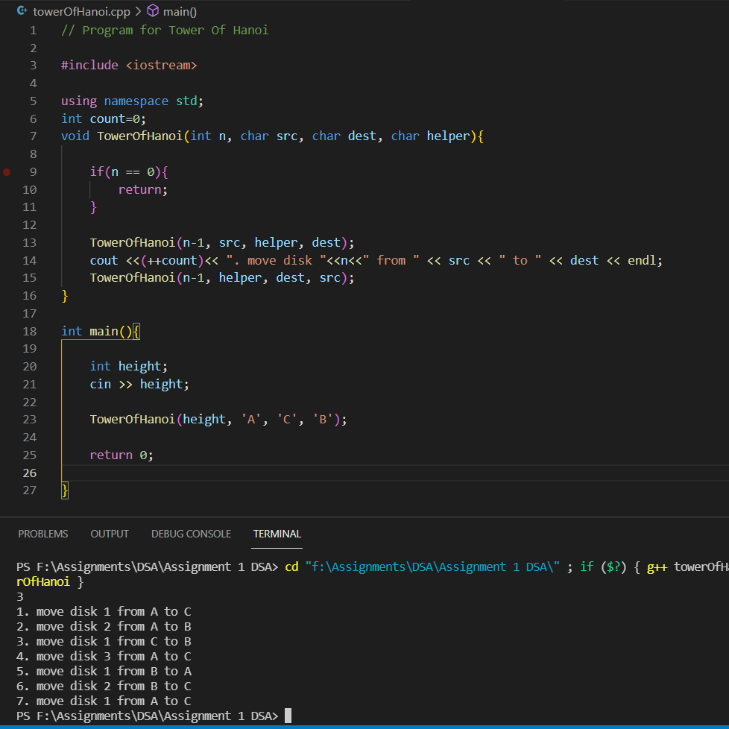

Q.4 Write a recursive program for Ackerman problem

Algorithm Ackermann(x,y)

Pre Function contains two values x and y

Post required result

1.if(x is 0)

1.return y+1

2.else if(x>0 and y is 0)

1.return (Ackermann((x-1),1)

3.else

1.return (Ackermann((x-1),Ackermann(x,(y-1)))

4.End if

End Ackermann

